CS 381 Project Stage 1

Noter

Evan Emsley – [eemsley@purdue.edu](mailto:eemsley@purdue.edu)

Noter is a social media web application that allows users to create accounts from which they can create notes. Notes can be seen by all users on the main page and can be edited or deleted by the users who create them. Additionally, users can grant other users access to edit or delete their notes. The main page and the user account page will also allow for filtering and searching of notes.

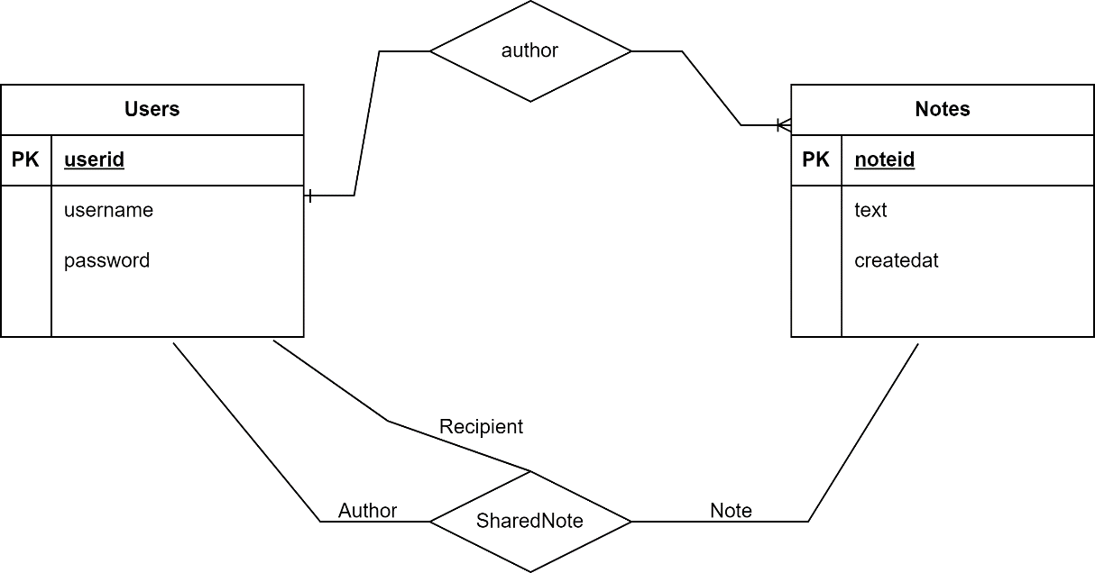

The database design will be as follows:

Users(**userid**, username, password)

Notes(**noteid**, text, createdat, *userid*)

SharedNote(*authorid*, *sharedid*, *noteid*)

*userid, authorid, sharedid are foreign keys to the users table

*noteid is a foreign key to the notes table

Here are some screenshots/mock-ups of the UI (campuswire said including screenshots is sufficient if we’ve begun development).

* The main page will consist of a list of notes, and I will eventually add a search bar and filtering options.
* The create note page will be a simple text box as seen, and the view note page will have an additional “share note” option.
* The top bar will also have a button to view the notes shared with you.

